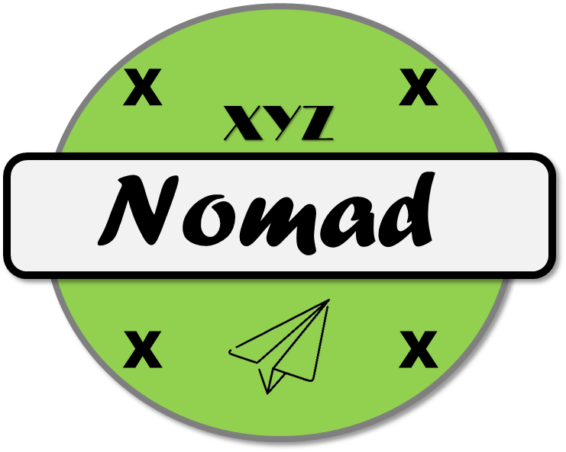

Final Payload Testing

25 November 2019

Version 1.1



645 Colonel Glenn Blvd

Dayton, Ohio

DISCLAIMER: This document has been produced to support training and experimentation ONLY. It does not represent any system, real or planned. No United States Government resources were used to produce this document.

**THIS PAGE IS INTENTIONALLY BLANK**

Contents

1. Introduction 5

2. Full Motion Video 5

2.1. Test 10-01 5

2.2. Test 10-02 5

2.2.1. Sensor Performance 5

2.2.2. Sensor Performance (High Resolution) 5

2.2.3. Sensor Performance (Long Range) 6

2.3. Test 10-03 6

2.3.1. Nighttime Performance 6

3. Wide Area Camera 7

3.1. Test 11-01 7

3.2. Test 11-02 7

3.2.1. Day Performance 7

3.2.2. Coverage Area 8

3.1. Test 11-03 8

3.1.1. Night Performance 8

4. Mission Control Software 8

4.1. Test 12-01 8

5. Power 9

5.1. Test 13-01 9

6. External Connections 9

6.1. Test 14-01 10

6.2. Test 14-02 10

**THIS PAGE IS INTENTIONALLY BLANK**

1. Introduction

The final payload testing was completed after the air vehicle design was completed, resulting in the Nomad-02 configuration. This configuration includes the updated FMV sensor, as well as the fully functional Wide Area Camera.

1. Full Motion Video
   1. Test 10-01

Test 10-01 was conducted to demonstrate positive control of the updated FMV sensor prior to executing qualitative tests at WPAFB. During the test, the air vehicle was held at 300 ft AGL, and the camera turret was moved to different targets.

|  |  |
| --- | --- |
| Test 10-01 Metadata |  |
| Date | 18 October 2019 |
| Location | Dayton, Ohio |
| Altitude | 900 ft MSL |
| Configuration | Nomad-02-02 |

During this test phase, the operator was able to pan, tilt and zoom the camera without restrictions. The camera was able to pan 360 degrees, and tilt from +10 to -90 degrees.

* 1. Test 10-02

Test 10-02 was executed on WPAFB’s resolution targets. Both the air vehicle and DGCS were located on WPAFB Area B during testing, which was conducted via line of sight.

|  |  |
| --- | --- |
| Test 10-02 Metadata |  |
| Date | 19 October 2019 |
| Location | WPAFB, Ohio |
| Altitude | 980 ft MSL |
| Configuration | Nomad-02-02 |

* + 1. Sensor Performance

The initial imaging test was conducted at 500 ft AGL, with a ground range to target of 75 feet.

|  |  |
| --- | --- |
| Test 10-02-01 |  |
| Time | 1330L |
| Slant Range to Target | 506 feet |
| Pointing Accuracy | 1.78 degree |
| Resolution | 0.09 meter |
| Framerate | 35 fps |

* + 1. Sensor Performance (High Resolution)

The high resolution imaging test was conducted at 500 ft AGL, with a ground range to target of 490 feet.

|  |  |
| --- | --- |
| Test 10-02-02 |  |
| Time | 1400L |
| Slant Range to Target | 700 feet |
| Pointing Accuracy | 1.75 degree |
| Resolution | 0.20 meter |
| Framerate | 32 fps |

* + 1. Sensor Performance (Long Range)

The high resolution imaging test was conducted at 500 ft AGL, with a ground range to target of 2400 feet.

|  |  |
| --- | --- |
| Test 10-02-03 |  |
| Time | 1430L |
| Slant Range to Target | 2480 feet |
| Pointing Accuracy | 1.80 degree |
| Resolution | 0.48 meter |
| Framerate | 33 fps |

* 1. Test 10-03

Test 07-02 was executed on WPAFB’s resolution targets during the night. Both the air vehicle and DGCS were located on WPAFB Area B during testing, which was conducted via line of sight.

|  |  |
| --- | --- |
| Test 10-03 Metadata |  |
| Date | 19 October 2019 |
| Location | WPAFB, Ohio |
| Altitude | 980 ft MSL |
| Configuration | Nomad-02-02 |

* + 1. Nighttime Performance

The night imaging test was conducted at 500 ft AGL, with a ground range to target of 500 feet. During testing the average illuminance was 0.83 lux.

|  |  |
| --- | --- |
| Test 10-03-01 |  |
| Time | 2300L |
| Pointing Accuracy | 2.3 degree |
| Illuminance | 1.05 lux |
| Slant Range to Target | 710 ft |
| Resolution | 0.68 meter |
| Framerate | 27 fps |

1. Wide Area Camera

The second sensor on Nomad is the wide area camera, which includes day and night cameras simultaneously installed on the air vehicle. This system is intended to provide wide area coverage to provide the operator situational awareness over a target area while the FMV system is used to identify and track targets.

* 1. Test 11-01

Test 11-01 was conducted to demonstrate positive control of the wide area camera system prior to executing qualitative tests at WPAFB. During the test, the air vehicle was held at 300 ft AGL, and the vehicle moved around the local are within line of sight of the DGCS.

|  |  |
| --- | --- |
| Test 11-01 Metadata |  |
| Date | 23 October 2019 |
| Location | Dayton, Ohio |
| Altitude | 900 ft MSL |
| Configuration | Nomad-02-02 |

During this test, the operator demonstrated the ability to take pictures in both the manual and automatic mode. In manual mode, the operator initiated a collection that took a single image directly beneath the air vehicle. In automatic mode, the vehicle moved along a path taking images at a constant rate.

* 1. Test 11-02

Test 11-02 demonstrated the performance of the wide area camera system in day operations and was executed on WPAFB’s resolution targets. Both the air vehicle and DGCS were located on WPAFB Area B during testing, which was conducted via line of sight. Test 11-02 was conducted in two different tests, 11-02-01 demonstrated the performance of the sensor, while 11-02-02 tested the coverage area of the sensor.

|  |  |
| --- | --- |
| Test 11-02 Metadata |  |
| Date | 25 October 2019 |
| Location | WPAFB, Ohio |
| Altitude | 980 ft MSL |
| Configuration | Nomad-02-02 |

* + 1. Day Performance

|  |  |
| --- | --- |
| Test 11-02-01 |  |
| Time | 1400L |
| Altitude | 1285 ft MSL |
| Latency | 2.2 seconds |
| Resolution | 0.45 meters |
| Framerate | 1.2 images per second |

* + 1. Coverage Area

|  |  |
| --- | --- |
| Test 11-02-02 |  |
| Time | 1500L |
| Altitude | 1500 ft MSL |
| Coverage Area | 382,000 sq ft |

* 1. Test 11-03

Test 11-03 demonstrated the performance of the wide area camera system in night operations and was executed on WPAFB’s resolution targets. Both the air vehicle and DGCS were located on WPAFB Area B during testing, which was conducted via line of sight.

|  |  |
| --- | --- |
| Test 11-03 Metadata |  |
| Date | 27 October 2019 |
| Location | WPAFB, Ohio |
| Altitude | 980 ft MSL |
| Configuration | Nomad-02-02 |

* + 1. Night Performance

|  |  |
| --- | --- |
| Test 11-03-01 |  |
| Time | 2200L |
| Altitude | 1250 ft MSL |
| Illuminance | 1.1 lux |
| Latency | 2.2 seconds |
| Resolution | 0.80 meters |
| Framerate | 1.2 images per second |

1. Mission Control Software

The DGCS v1 capability implemented the full functionality of the final Nomad mission control capability. The capability was partially tested during Test 09-01, but full testing was not available due to lack of weather and threat simulation data as well a lack of wide area imagery.

* 1. Test 12-01

For Test 12-01, the full mission control capability was demonstrated. Testing was conducted using the air vehicle to collect wide area imagery, and with locally simulated data for the COP.

|  |  |
| --- | --- |
| Test 12-01 Metadata |  |
| Date | 28 October 2019 |
| Location | Dayton, Ohio |
| Altitude | 900 ft MSL |
| Configuration | Nomad-02-02 |

During the test, the system successfully display the health and status of each Nomad system. The COP was used to successfully display both Blue Force and weather data that were locally generated. However, the simulator intended to display the threat data was not operational in time for the test. Rather than delay the full test, XYZ decided to delay demonstrating the threat data until the live data was available in the external connection test.

During testing the DCGS was not able to succeed in re-transmitting the wide area imagery. In operations, the re-transmit capability is intended to be used for the operator to access images that failed to send, or that were collected outside of payload link range. During testing, the operator was not able to navigate to folder on the air vehicle that stored the files. Because of this, he was not able to re-transmit the files. Testing is ongoing to identify the issue.

1. Power

A key component of the DGCS is its ability to rapidly deploy in rugged areas. As part of this capability, the DGCS is provisioned with a large battery to enable extended multi-mission operations. The DGCS also has the ability to be connected to shore power, but the DGCS v1 configuration shore power supply was not representative of the final planned design.

* 1. Test 13-01

Test 13-01 demonstrated the battery life of the DGCS. Testing was conducted without the air vehicle in flight by powering all air vehicle payloads on, as well as both the control link and payload link. This ensured that the full processing capability of the DGCS was executing, resulting in full power load.

|  |  |
| --- | --- |
| Test 13-01 Metadata |  |
| Date | 28 October 2019 |
| Location | Dayton, Ohio |
| Altitude | 900 ft MSL |
| Configuration | Nomad-02-02 |

Test 13-01 was conducted at multiple load rates, including maximum load. It was also conducted with all payloads turned off, and with only the FMV operating.

|  |  |
| --- | --- |
| Test 13-01-01 |  |
| Time | 1200L |
| Vehicle Only | 10 hours |
| FMV Only | 6 hours |
| Maximum Load | 5 hours |

1. External Connections

A key feature of the OTSS-E capability is the ability to connect with external sources to both receive and send data. Data provided to Nomad from external sources is used to update the COP, ensuring that the operator has the most up to date tactical information. Information provided from Nomad is sent to units operating tactically with the Nomad operator.

* 1. Test 14-01

Test 14-01 demonstrated Nomad’s ability to receive data from multiple sources, including both Blue Force (friendly) and threat data. The test was conducted by connecting the DGCS to a data stimulator via a 1 GbE network connection. Simulated data was then streamed from the remote simulator to the DGCS.

|  |  |
| --- | --- |
| Test 14-01 Metadata |  |
| Date | 1 November 2019 |
| Location | Dayton, Ohio |
| Altitude | 900 ft MSL |
| Configuration | Nomad-02-02 |

During this test, the DGCS was able to receive both Blue Force and threat data. Blue Force data was provided in Universal Command and Control Interface (UCI) format as XML files, while the threat data was provided as MIL-STD-6016 compliant data.

* 1. Test 14-02

Test 14-02 demonstrated Nomad’s capability to send imagery to external sources. During this test, the operator utilized both the automatic and manual modes to collect wide area imagery. The external source was an image viewer connected to the DGCS via a 1 GbE network connection,

|  |  |
| --- | --- |
| Test 14-02 Metadata |  |
| Date | 2 November 2019 |
| Location | Dayton, Ohio |
| Altitude | 900 ft MSL |
| Configuration | Nomad-02-02 |

Once the images were collected, processed and sent to the ground station, the operator manually selected and transmitted them to the external viewer as National Imagery Transfer File (NITF) 2.1 compliant images. The external viewer was able to unpack and view these files.